The Metric System
Meters, Grams and Liters

- The metric system is a measurement system based on our decimal (base 10) number system.
- Other countries and all scientists and engineers use the metric system for ______________________.
Measurement Systems
There are ___ types of measurement systems:
What are the two measurements systems?
________________________
________________________
Metric Prefixes

The metric system has prefix modifiers that are multiples of 10.
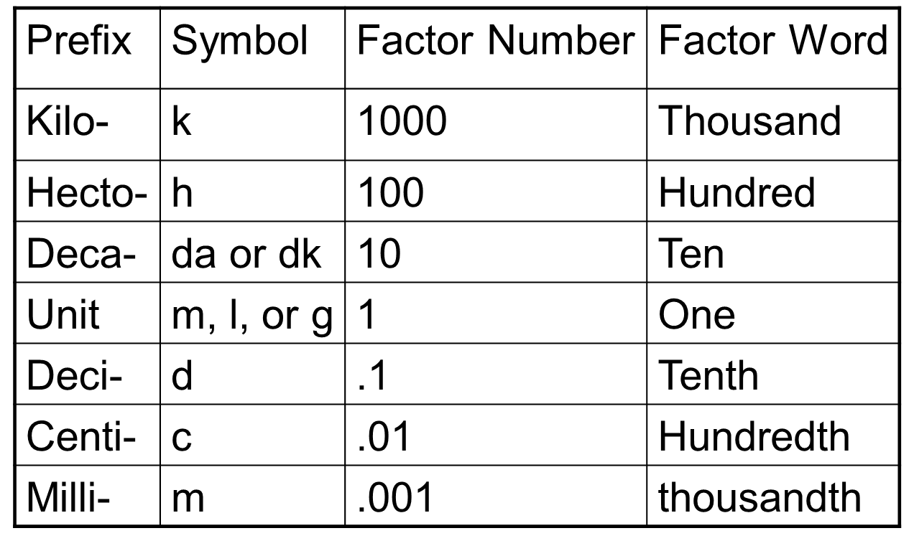
Meters
Meters measure _________________ or __________________
Millimeters
One millimeter is about the thickness of a ____________.
10 mm = _______________
Centimeters
- One centimeter is about the width of a large paper clip
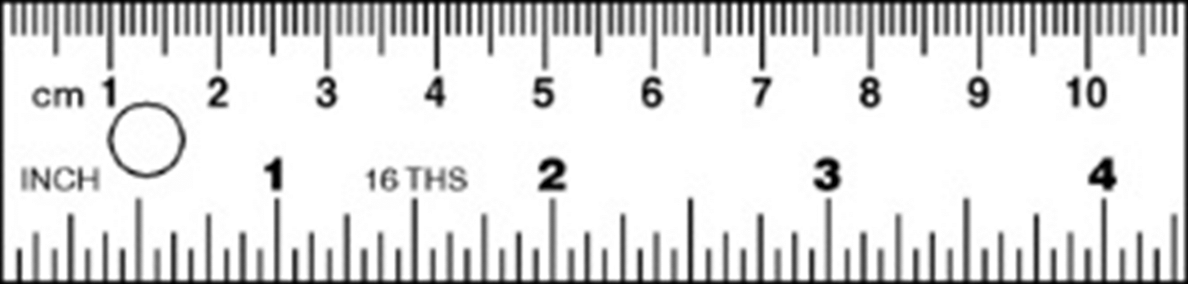
Meter
A meter is about the width of a doorway
Kilometer
A kilometer is about six city blocks or 10 football fields.
1.6 kilometers is about ______________
AND 1 kilometer is about ____________
The Gram
Grams are used to measure mass or the __________________________ of an object.
Please get familiar with this now. We will use the gram quite frequently this year especially when we use the triple beam balance.
Milligrams
A milligram weighs about as much as a grain of ________________.
Gram
1 gram weighs about as much as a small _______________________.
Kilogram
1 kilogram weighs about as much as 6 apples or ______________________.
The Liter
Liters measure liquids or capacity. The liter unit is used when measuring ________________________________.
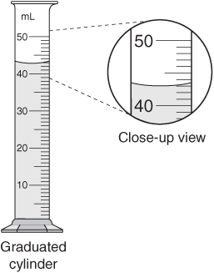
Milliliter
1 milliliter is about the amount of _______________.
We use the milliliter often when using ______________________.
Liter
1 liter is ____________ of a 2 liter bottle of Coke or other soda
Kiloliter
A kiloliter would be about __________ 2-liter bottles of pop

Why do we use the metric system here in America?

