**7th Grade Integrated Science**

**Standard III, Objective 2**

**Title: Reverse Dissection**

**Description:** Students use paper frog organs to reassemble frog organ systems.

**Materials:** Frog organs and frog outline (see below), resources such as textbooks or Internet, colored pencils or markers, Scotch tape or glue, scissors

**Time Needed:** 50-100 minutes depending on student background and availability of resource materials.

## **Background:** Students are working on being able to identify and describe the

## function and interdependence of various organs and tissues. They may be able to do the indicators below at the beginning of the activity or the end, this can be used as a summative or formative activity.

1. Order the levels of organization from simple to complex (e.g., cell, tissue, organ, system, organism).
2. Match a particular structure to the appropriate level (e.g., heart to organ, cactus to organism, muscle to tissue).

c. Relate the structure of an organ to its component parts and the larger system of which it is a part.

**Procedures:**

1. “Hook” students with a short video or video clip showing a real live frog in its habitat. Discuss the things a frog’s body has to be able to do for it to carry out life functions. See if students can match body organs or organ systems to the frogs needs.

2. Give students or student groups the papers with the frog organs and frog outline and read the student page with them. Show students what resource materials are available for them to use for help.

3. Allow time for students to cut and paste. Ask students to check off their frog with you before answering the analysis questions. A key diagram is included on the pages below

4. There are many “virtual” frog dissections on the Internet. You may wish for your students to try one of them after doing this activity. Here are a couple of sites you might use:

<http://www-itg.lbl.gov/ITG.hm.pg.docs/dissect/info.html>

<http://www.ofsd.k12.wi.us/science/frogdiss.htm>l

**Scoring Guide:**

1. Students correctly place the frog organs in the frog……………4

2. Students answer analysis questions correctly…………………..4

Answer: a. frogs must exchange gases with the air, eat and digest food, move substances around their bodies, move their bodies, support their bodies, clean and manufacture their blood, respond to the environment,

b. circulatory, respiratory, digestive, musculature, skeletal, urinary, nervous

c. mouth, esphogus, stomach, small and large intestine,

d. cells

e. the stomach is sack shaped and shows that it hold something

3. Students correctly write the summary paragraph……………….4

Name ______________________________ Due Date ______________________ Period _____

**Reverse Frog Dissection**

**Introduction:** You may have never seen the inside of a real organism and may not think you want to. Most people are squeamish at first when they see real organs but quickly discover that living organisms are amazingly complex and interesting. In this activity, you will see a model of a frog and its organ systems. You will put the paper frog back together and learn about the organ systems that allow the frog to carry out its life functions.

**Materials:** Paper frog organs and frog outline (see below), Internet, colored pencils or markers, scotch tape or glue, scissors

**Helpful Websites**

http://www.froguts.com/demo/ <http://www.mhhe.com/biosci/genbio/virtual_labs/BL_16/BL_16.html>

**Procedures:**

1. Watch the whole “froguts” frog dissection demo and participate along with it before you begin your reverse frog dissection.
2. Color and cut out the organs.
3. Glue the frog on a separate sheet of paper and decide where they need to fit in the frog’s body. You may use the internet to help you.
4. Check with your teacher before you glue or tape the organs.
5. Label your organs.
6. Compare your results with other students. See if they all look alike.
7. Answer the analysis questions a-d below.
   1. What are at least 3 body functions a frog must be able to perform for it to live?
   2. What organ systems are found in a frog?
   3. What are organs in the digestive system?
   4. What are organs made from? How many different types are there?
8. Choose one organ system and describe what would happen to the frog without that system. Be specific; don’t just say that it would die. Your answer should be at least 3-5 COMPLETE SENTENCES long.

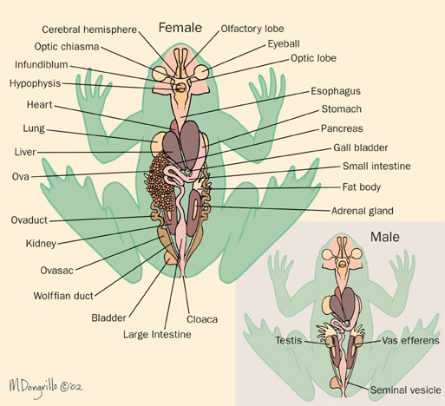

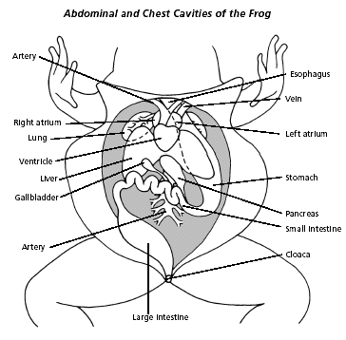

**Color and cut out this page**



Teacher Key