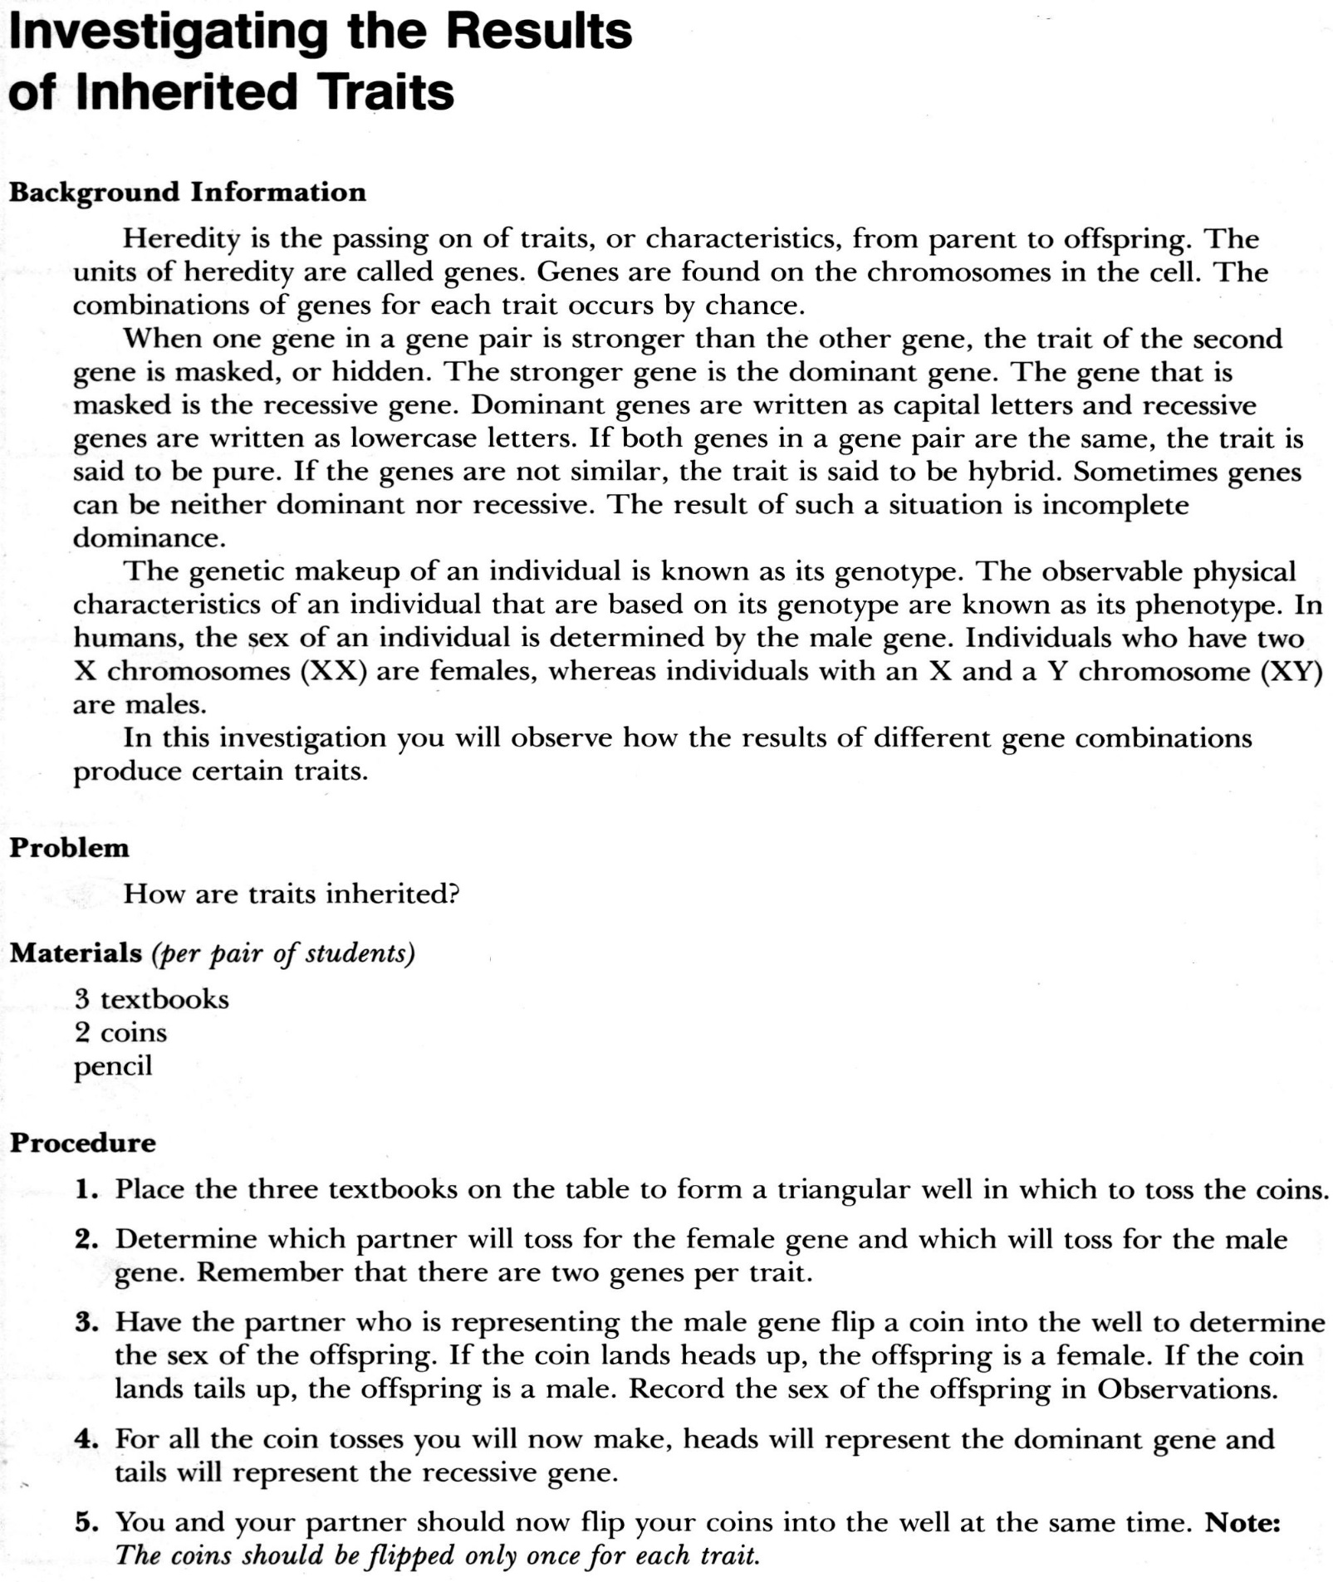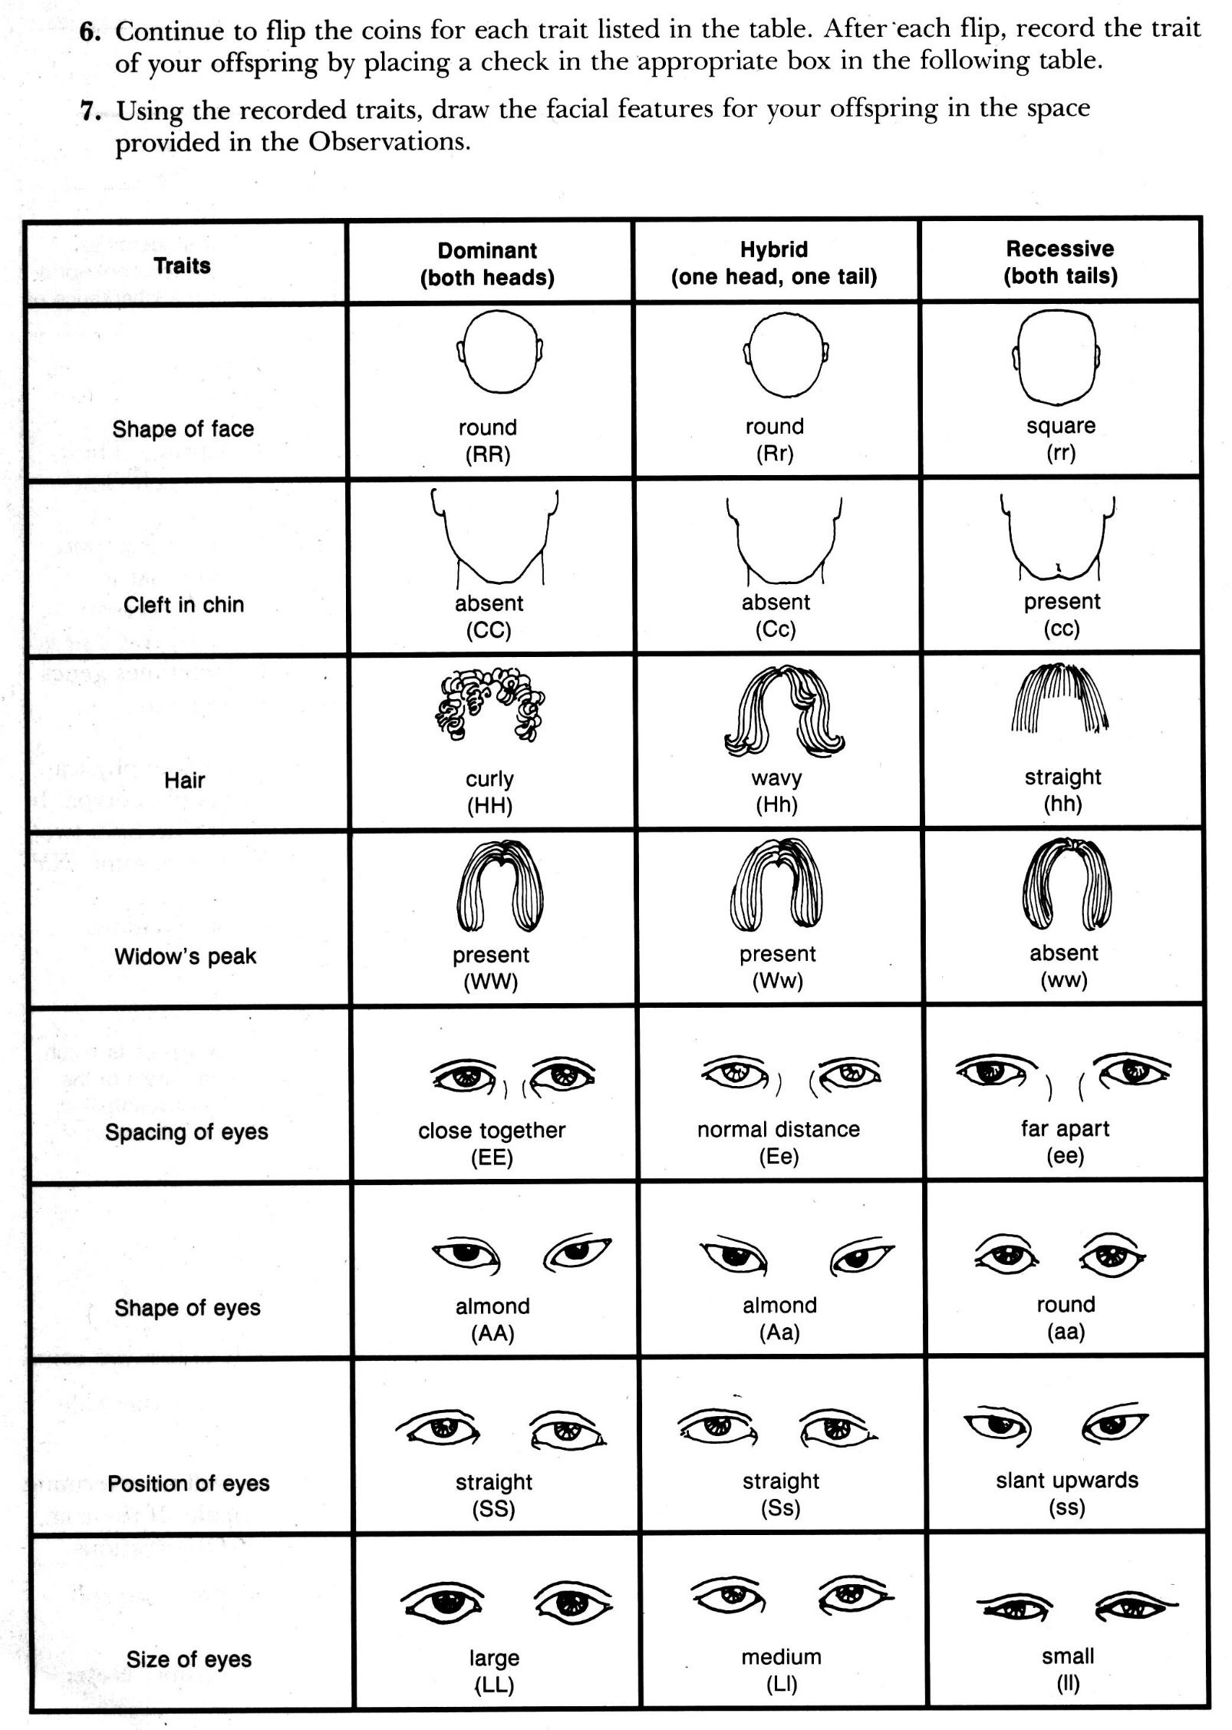Name ______________________________ Date _______________ Period _______

Skip to procedure #2

2 Coins

Colored Pencils

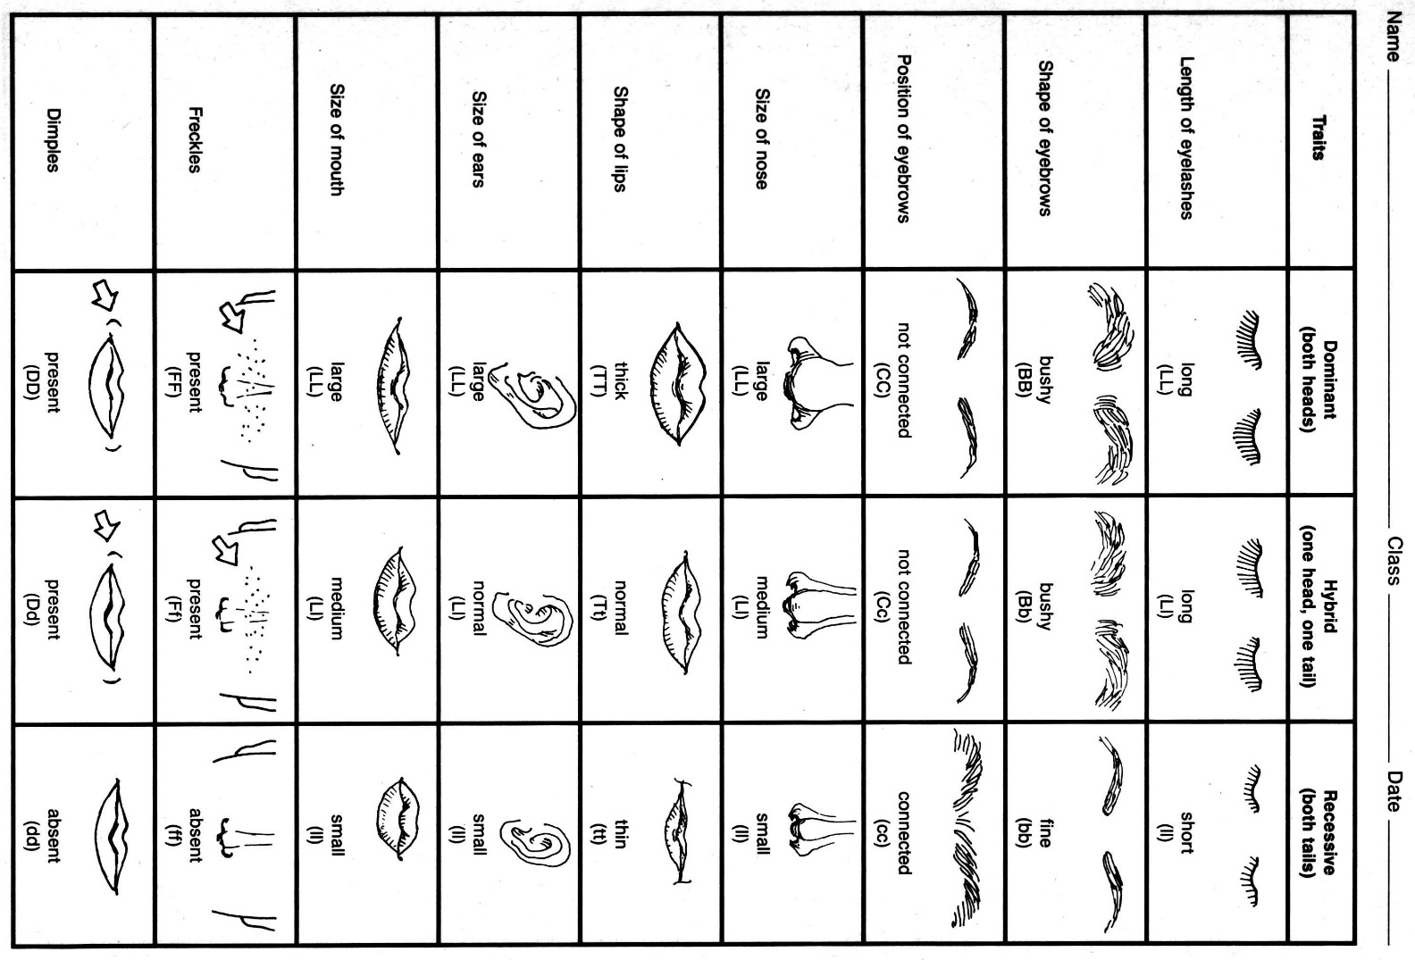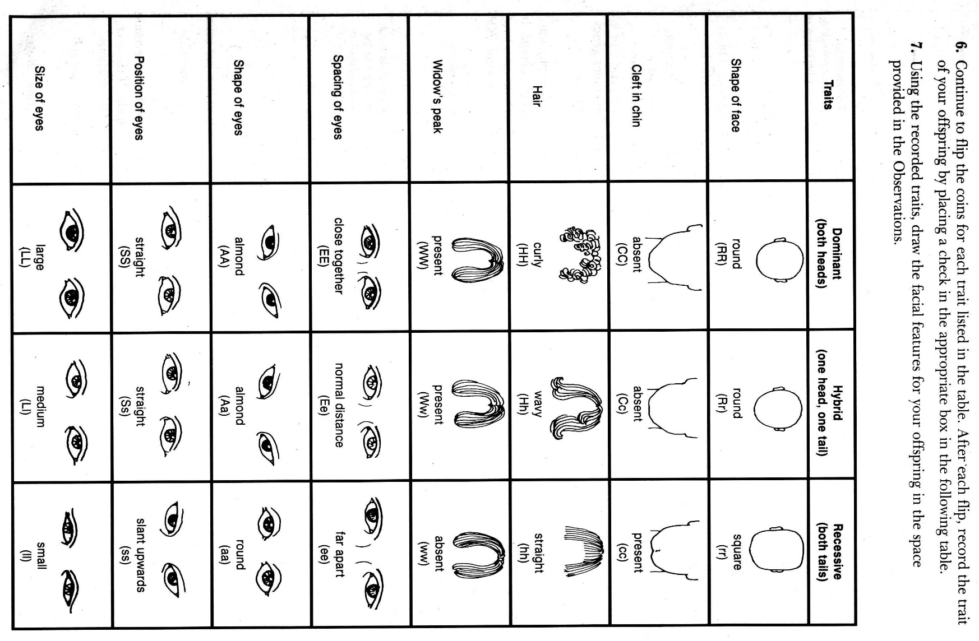b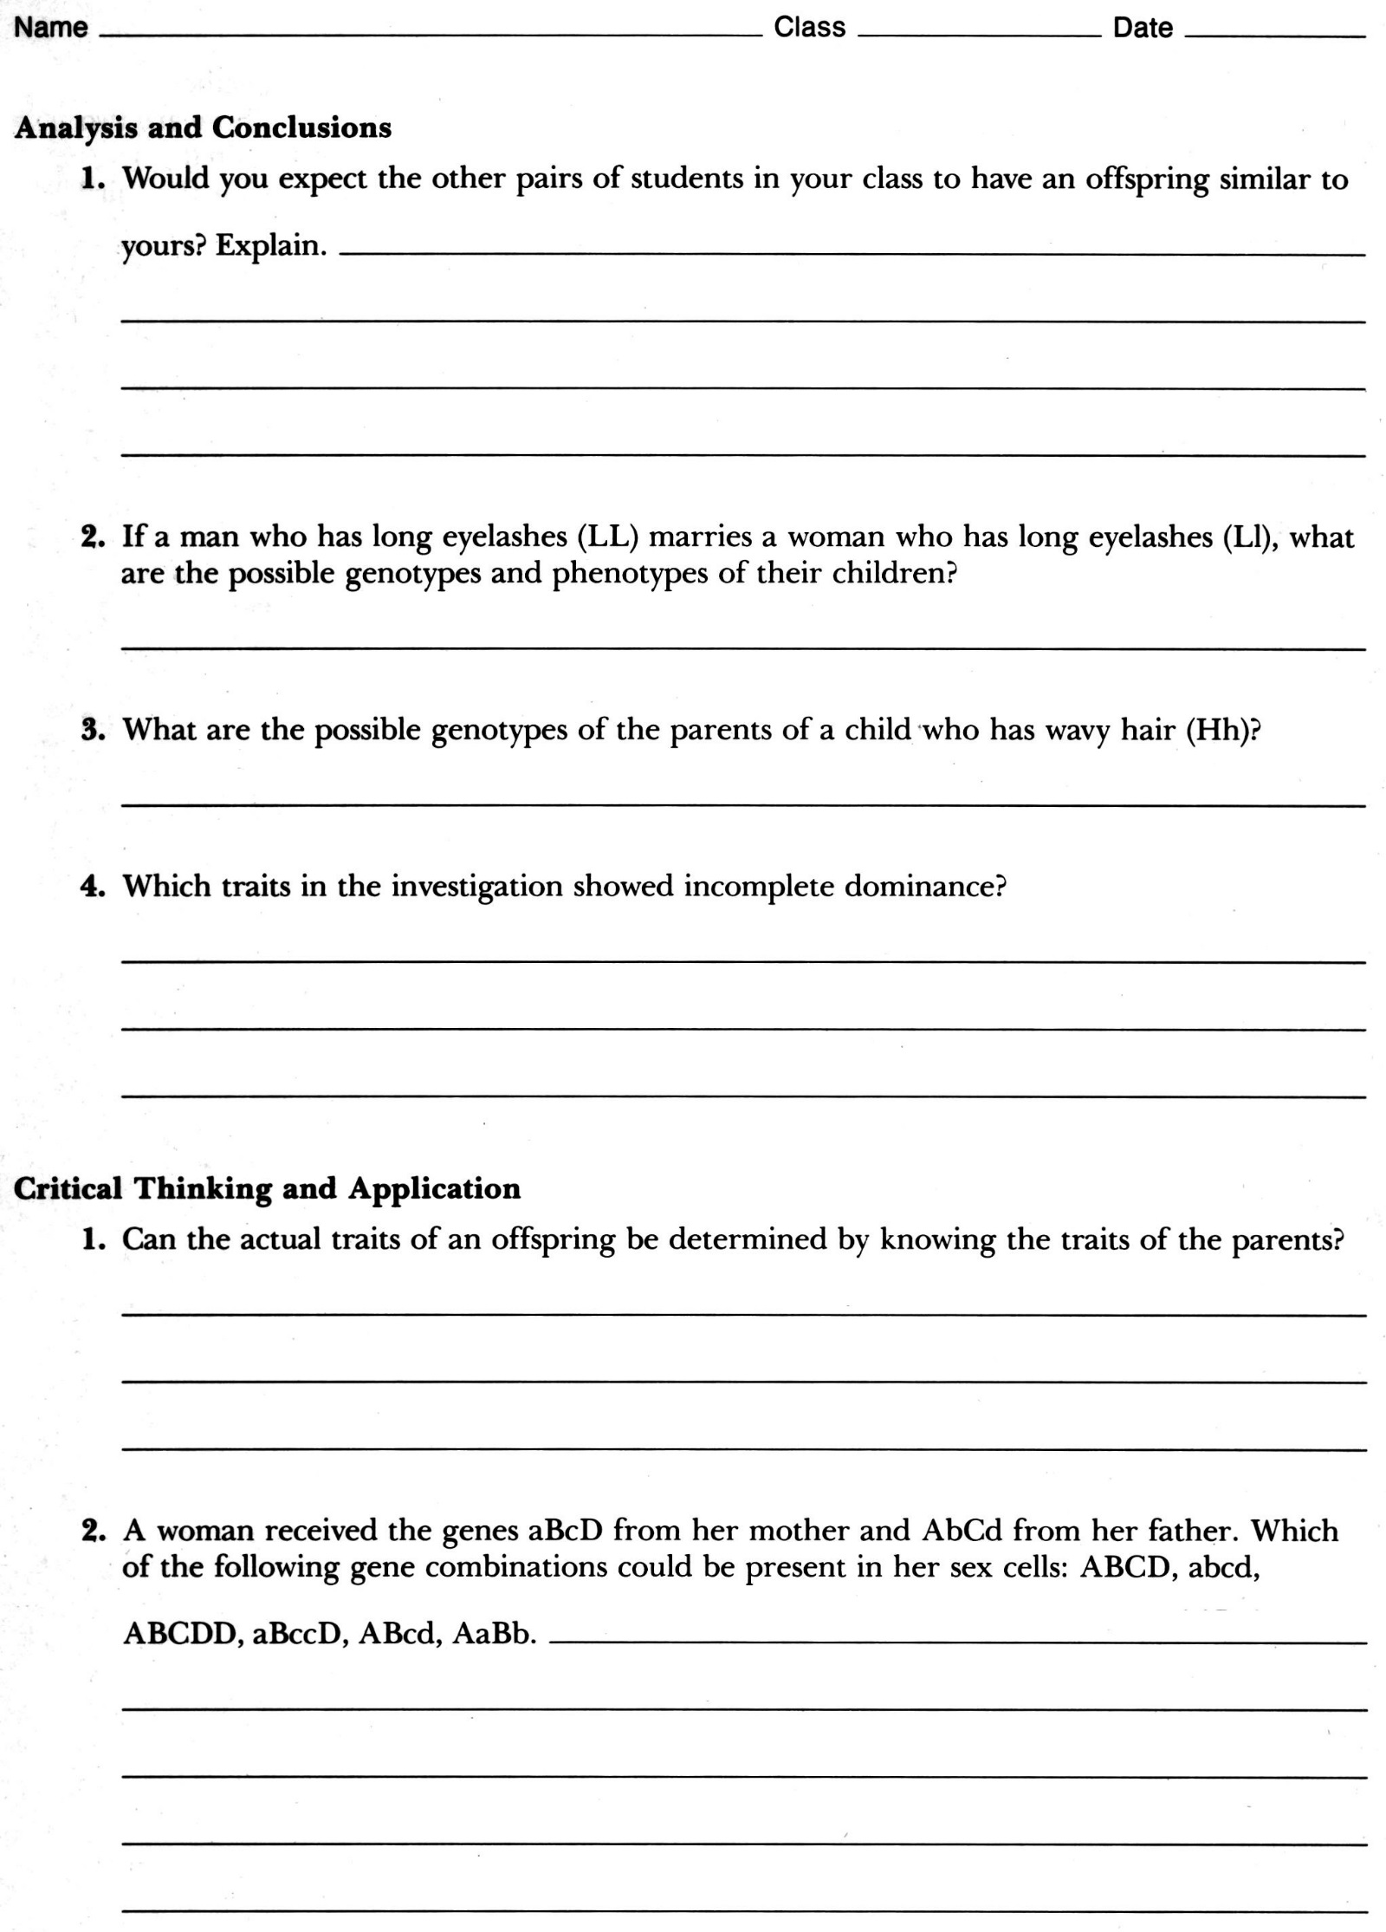Name of offspring___________________________________________________________________

Sex of offspring __________________