Name: Period: Date:

The Letter “e”
Introduction to Microscopes Lab

Objective:
- To learn the parts of the microscope
- To find specimens using low and high power
- To make a wet mount
- To learn how to use the microscope

Procedure: Part 1: Identify and Label Microscope Parts
Use the diagram of a microscope provided to identify the parts of the microscope in front of you. On the diagram label the microscope parts and write what they do.

Procedure: Part 2: Letter “e”

- Cut out a letter “e” from the paper provided
- Observe it with only your eyes.
- In Data section below, draw what you see in Figure 1. Try drawing to scale.

- Now place the “e” on the slide face up.
- Add a drop of water to the slide
- Place a cover slip on top of the “e” and drop of water at a 45-degree angle and lower it gently. Draw what is on the slide in Data Figure 2 below.

- Now place the slide on the stage and secure it with the stage clips. View the slide under low power (4x). Center the “e” in your field of view. First use the coarse focus and then the fine focus knobs to make your image clear. Draw what you see in Figure 3 in Data below.

- Move the slice to the left. What happens? Move the slide to the right. What happens? Up? Down? Record findings in Data section.

- View the letter “e” in high power (10x). Use the fine focus adjustment only to focus. Draw what you see in Figure 4 in Data below.

YOU MUST CLEAN UP! ALL SLIDES ARE TO BE RINSED AND PLACED ON A PAPER TOWEL BY THE SINK TO DRY! COVER SLIPS AND LETTER e SHOULD BE THROWN OUT.
Data: Letter “e”
Figure 1: Drawing of letter “e” eye observation:

Figure 2: Drawing of the letter “e” on the slide:

Figure 3: Drawing of the letter “e” in low power (4x):

Figure 4: Drawing of the letter “e” in high power (10x):

Analysis:
- How does the letter “e” as seen through the microscope differ from the way an “e” normally appears?

- When you move the slide to the left, in what direction does the letter “e” appear to move? When you move it to the right? Up? Down?

- How does the ink appear under the microscope compared to normal view?

- Why does a specimen placed under a microscope have to be thin?

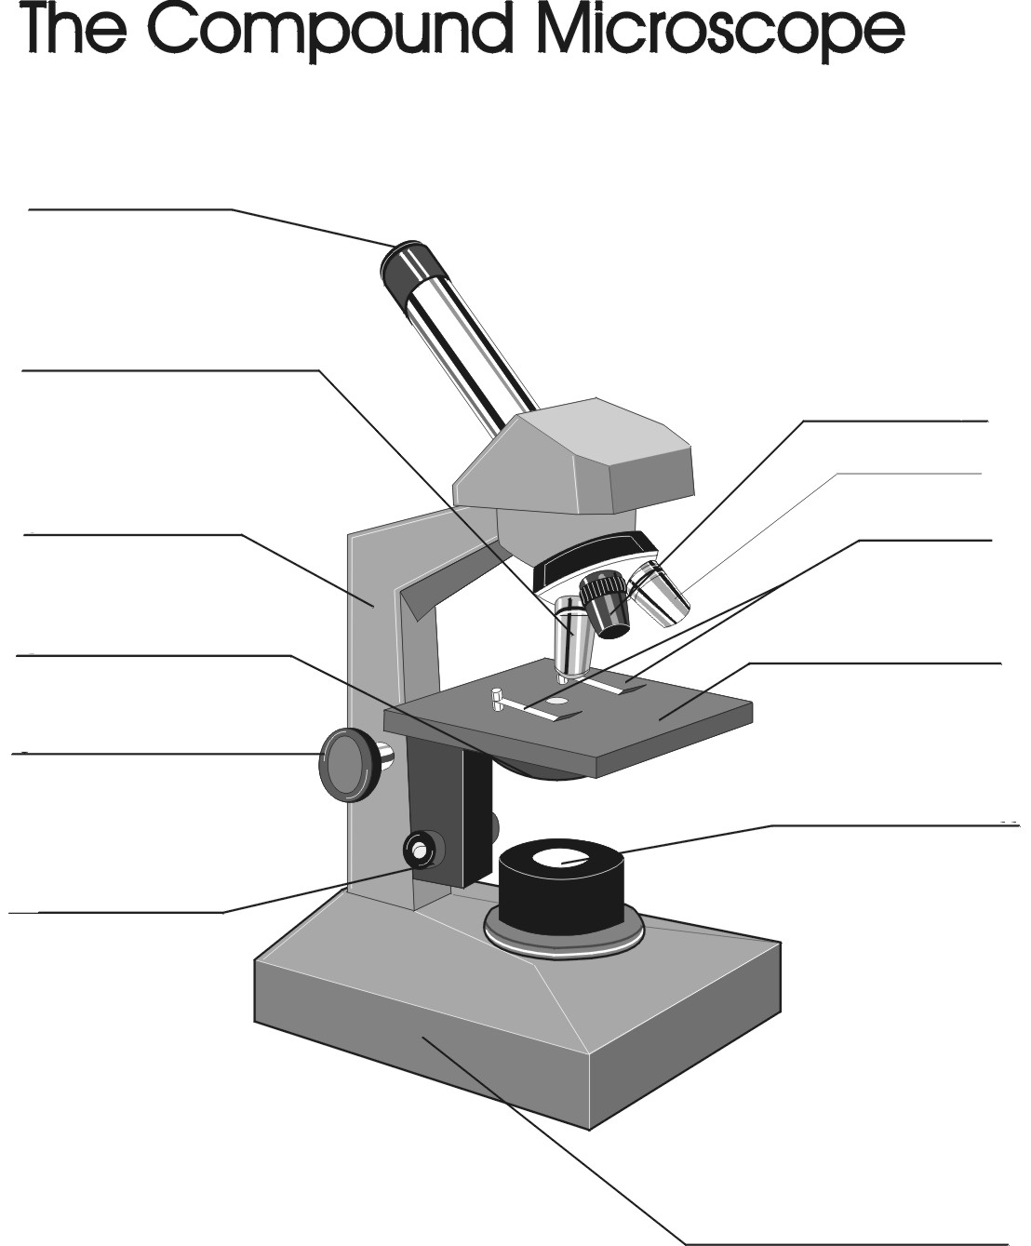
- If you are looking at a specimen on a slide at the 4x magnification, what is the actual magnification level? ____________
- If you are looking at a specimen on a slide at the 10x magnification, what is the actual magnification level? ____________
- If you are looking at a specimen on a slide at the 40x magnification, what is the actual magnification level? ____________

Scoring Guide:
Category | Possible Points | Points Earned
Parts of microscope correctly labeled and their function explained | 12
Data- Drawings carefully, clearly, and accurately done | 8
Analysis questions answered thoughtfully and correctly | 8
Total points | 28

