Name___________ Period__

Taxonomy, Classification, and Dichotomous Keys
Help! Scientists have discovered quite a few new creatures on planet Pamishan. They need your help to identify and classify them. Use the dichotomous key on the next page to identify these creatures.
1. 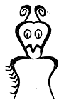 | 2. 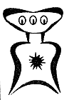 | 3. 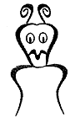 | 4. 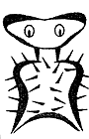 | 5. 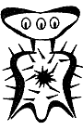
6. 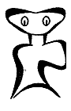 | 7. 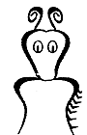 | 8. 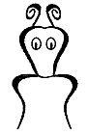 | 9. 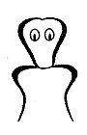 | 10. 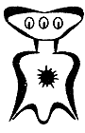
11. 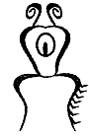 | 12. 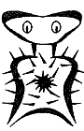 | 13. 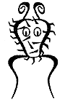 | 14. 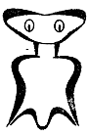 | 15. 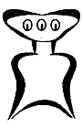
16. 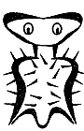 | 17. 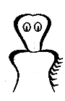 | 18. 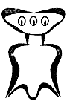 | 19. 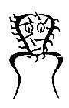 | 20. 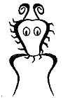

A Key to New Pamishan
1. | a. The creature has a large wide head............................go to 2
 | b. The creature has a small narrow head..........................go to 11
2. | a. It has 3 eyes ................................................go to 3
 | b. It has 2 eyes ................................................go to 7
3. | a. There is a star in the middle of its chest....................go to 4
 | b. There is no star in the middle of its chest ..................go to 6
4. | a. The creature has hair spikes .................................Broadus hairus
 | b. The creature has no hair spikes...............................go to 5
5. | a. The bottom of the creature is arch-shaped ....................Broadus archus
 | b. The bottom of the creature is M-shaped .......................Broadus emmus
6. | a. The creature has an arch-shaped bottom .......................Broadus plainus
 | b. The creature has an M-shaped bottom...........................Broadus tritops
7. | a. The creature has hairy spikes ................................go to 8
 | b. The creature has no spikes....................................go to 10
8. | a. There is a star in the middle of its body ....................Broadus hairystarus
 | b. The is no star in the middle of its body .....................go to 9
9. | a. The creature has an arch shaped bottom .......................Broadus hairyemmus
 | b. The creature has an M shaped bottum ..........................Broadus kiferus
10. | a. The body is symmetrical ......................................Broadus walter
 | b. The body is not symmetrical...................................Broadus anderson
11. | a. The creatrue has no antennae .................................go to 12
 | b. The creature has antennae ....................................go to 14
12. | a. There are spikes on the face .................................Narrowus wolfus
 | b. There are no spikes on the face ..............................go to 13
13. | a. The creature has no spike anywhere ...........................Narrowus blankus
 | b. There are spikes on the right leg ............................Narrowus starboardus
14. | a. The creature has 2 eyes.......................................go to 15
 | b. The creature has 1 eye........................................Narrowus cyclops
15. | a. The creature has a mouth......................................go to 16
 | b. The creature has no mouth.....................................go to 17
16. | a. There are spikes on the left leg .............................Narrowus portus
 | b. There are no spikes at all ...................................Narrowus plainus
17. | a. The creature has spikes ......................................go to 18
 | b. The creature has no spikes ...................................Narrowus georginia
18. | a. There are spikes on the head .................................go to 19
 | b. There are spikes on the right leg.............................Narrowus montanian
19. | a. There are spikes covering the face ...........................Narrowus beardus
 | b. There are spikes only on the outside edge of head ............Narrowus fuzzus

