Review: Pg. 322

Name \_\_\_\_\_\_\_\_\_\_\_\_\_\_\_\_\_\_\_Period \_\_\_\_

**Introduction**.

1. What is an organelle?

**Enter the Cell**

2. The rigid layer of nonliving material that surrounds plant cells is the \_\_\_\_\_\_\_\_\_\_\_\_\_\_\_\_\_\_\_\_\_\_\_\_\_\_\_\_\_\_\_\_\_\_\_

3. *Circle the letter of each sentence that is true about the cell wall.*

a. Cell walls are made of cellulose c. Animal cells have cell walls.

b. Plant cells have cell walls. D. Water and oxygen cannot pass through the cell wall.

4. What does the cell wall do?

5. Where is the cell membrane located in cells that have cell walls?

6. Where is the cell membrane located in cells that DO NOT have cell walls?

7. *True or False.* ***If false, change the statement to make it correct****. (no credit if false & not corrected)*

The main function of the cell membrane is to control what comes into and out of a cell.

**Sail On To the Nucleus**

8. *Circle the letter of each sentence that is true about the nucleus.*

a. Materials pass in and out of the nucleus through pores in the nuclear envelope

b. Chromatin contains the instruction that direct the functions of a cell.

c. The nucleolus part of the nuclear envelope.

d. Ribosomes are made in the nucleolus.

**Organelles in the Cytoplasm**

9. *Circle the letter of the part of the cell that is the region between the cell membrane and the nucleus.*

*a. organelle c. cytoplasm*

*b. nucleus d. chromatin*

**Building Vocabulary** Fill in the blanks (with words from the list below) to complete each statement.

Cell Membrane

Cell Wall

Chloroplasts

Cytoplasm

Endoplasmic Reticulum

Golgi Bodies

Lysosomes

Mitochondria

Nucleus

Organelles

Ribosomes

Vacuole

10. \_\_\_\_\_\_\_\_\_\_\_\_\_\_\_\_\_\_\_\_\_\_\_are tiny cell structures that carry out specific functions within the cell.

11. The rigid layer of nonliving material that surrounds the cells of plants is called the \_\_\_\_\_\_\_\_\_\_\_\_\_\_\_.

12. In cells without cell walls, the \_\_\_\_\_\_\_\_\_\_\_\_\_\_\_\_\_\_\_\_\_\_\_\_\_\_ forms the outside boundary that separates the cell from its environment.

13. The \_\_\_\_\_\_\_\_\_\_\_\_\_\_\_\_\_\_\_\_\_is a large, oval structure that directs all of the cell’s activities.

14. The region between the cell membrane and the nucleus is called the \_\_\_\_\_\_\_\_\_\_\_\_\_\_\_\_\_\_\_\_\_\_\_\_\_\_\_\_\_.

15. \_\_\_\_\_\_\_\_\_\_\_\_\_\_\_\_\_\_\_\_\_\_\_\_\_\_\_\_\_\_\_\_\_ produce most of the energy the cell needs to carry out its functions.

16. A maze of passageways is called the \_\_\_\_\_\_\_\_\_\_\_\_\_\_\_\_\_\_\_\_\_\_\_\_\_\_\_\_\_\_\_\_\_\_\_\_\_\_\_\_\_\_\_\_\_\_\_\_\_\_\_\_\_\_\_\_\_\_\_carries proteins and other materials from one part of the cell to another.

17. \_\_\_\_\_\_\_\_\_\_\_\_\_\_\_\_\_\_\_\_\_\_\_\_\_ function as factories to produce proteins.

18. Organelles called \_\_\_\_\_\_\_\_\_\_\_\_\_\_\_\_\_\_\_\_\_\_\_\_\_\_\_\_\_\_ capture energy from sunlight and use it to produce food for the Plant Cell.

19. \_\_\_\_\_\_\_\_\_\_\_\_\_\_\_\_\_\_\_\_\_\_\_\_\_\_\_\_\_\_\_\_\_\_\_\_\_receive proteins and other newly formed materials and distribute them to other parts of the cell.

20. The storage area of a cell is called a(n) \_\_\_\_\_\_\_\_\_\_\_\_\_\_\_\_\_\_\_\_\_\_\_\_\_\_\_\_\_\_\_\_\_\_\_\_\_\_\_.

21. \_\_\_\_\_\_\_\_\_\_\_\_\_\_\_\_\_\_\_\_\_\_\_\_\_\_\_\_\_\_\_\_\_ are small, round structures in cells that break down large food particles into smaller ones and break down substances to be used again.

**CELL CITY:** The *figure below shows a city that is a model for a cell. Study it and use it to fill in the data table.*

|  |  |  |
| --- | --- | --- |
| # of  city  part | Function of city part | Cell part with same function |
| 1 |  |  |
| 2 |  |  |
| 3 |  |  |
| 4 |  |  |
| 5 |  |  |
| 6 |  |  |
| 7 |  |  |
| 8 |  |  |

Name \_\_\_\_\_\_\_\_\_\_\_\_\_\_\_\_\_\_\_\_\_\_\_\_\_\_\_ Period \_\_\_\_\_\_\_

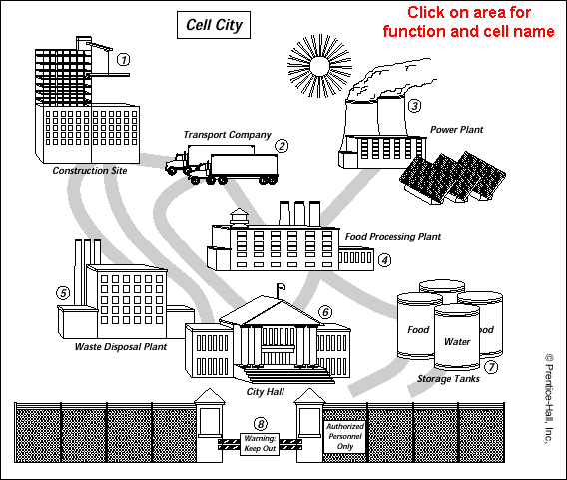

|  |  |  |
| --- | --- | --- |
| \_\_\_\_22) | A student wants to look at the chloroplast in the one-celled organism called Euglena. Which instrument would he use? | |
|  | A. | compound microscope |
|  | B. | telescope |
|  | C. | the naked eye |
|  | D. | magnifying glass |

|  |  |  |
| --- | --- | --- |
| \_\_\_\_23) | Two students set up two experiments to see if both plant and animal cells have cell walls. Which of the following statements best describes correct conclusions? | |
|  | A. | Both student experiments show that plant cells have cell walls and animal cells do not have cell walls so it does not matter that each student used different experimental methods and procedures |
|  | B. | Both experiments showed that plant cells and animal cells have cell walls so it does not matter that each student used different experimental methods and procedures |
|  | C. | Both experiments showed that plant cells have cell walls and animal cells do not have cell walls so the two students obviously did the exact same experiment so they could get the same conclusion |
|  | D. | Both experiments showed that plant cells and animal cells have cell walls so the two students obviously had the same exact experiment so they could get the same conclusion |

|  |  |  |
| --- | --- | --- |
| \_\_\_\_24) | This question refers to the following diagram of a plant cell. Be able to identify A,B,C,D.  7th_31_3.gif  Which cell part is primarily responsible for the movement of materials into and out of the cell? | |
|  | A. | A |
|  | B. | B |
|  | C. | C |
|  | D. | D |

\_\_\_\_25) The movement of water across a selectively permeable membrane is called

1. admission
2. Exclusion
3. Osmosis
4. Diffusion

|  |  |  |  |  |  |
| --- | --- | --- | --- | --- | --- |
| \_\_\_\_26) | Sarah put a carrot slice in a beaker of cold salty water and another slice from the same carrot in a beaker of cold fresh water. After an hour, she found that the one in the fresh water was much crispier than the one in the salt water. Which answer best explains her findings? | | | | |
|  | A. | | the fresh water slice must have come from a crisper carrot | | |
|  | B. | | the fresh water slice must have been smaller | | |
|  | C. | | the fresh water in the beaker absorbed water from the cells of the carrot slice | | |
|  | D. | | fresh water in the beaker went into the cells of the carrot slice | | |
| \_\_\_\_27) | | A cell that is 35% water is placed in a solution that is 50% water. Which way will the net movement of water go? | | |
|  | | A. | | Into the cell |
|  | | B. | | Out of the cell |
|  | | C. | | Neither way |

