Name ______________________________ Date ____________________ Period __________
Calculating Density Two
What is the mass displayed on each of the triple beam balances below? Write your answer (including units) in the box to the right of the picture

1.

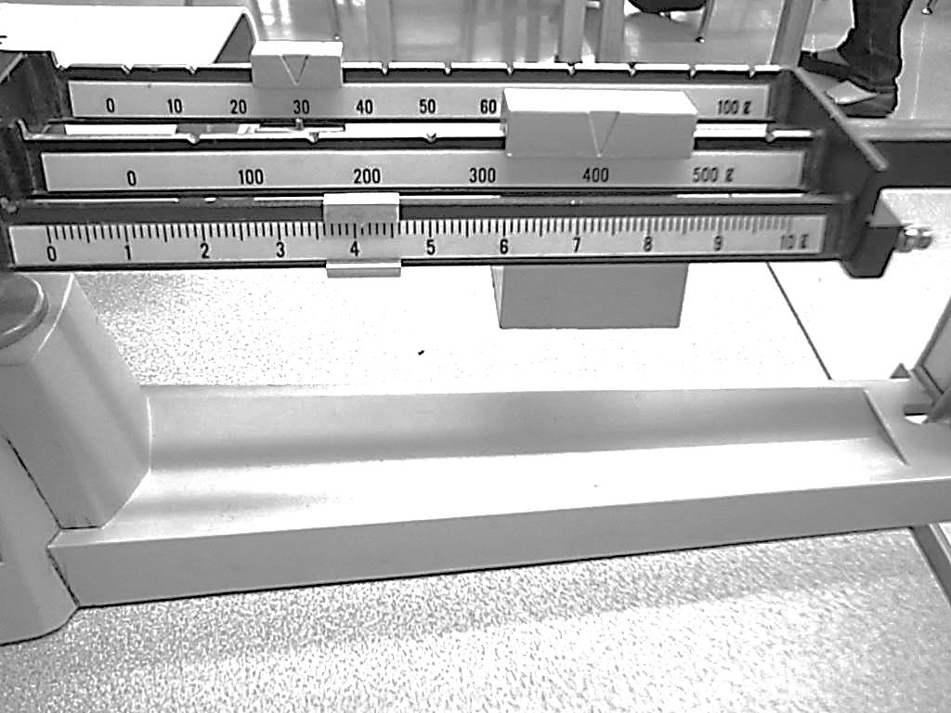
2.

3.

What is the volume displayed on each of the graduated cylinders below? Write your answer (including units) in the box below each picture.

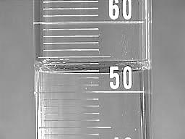
4. 5.

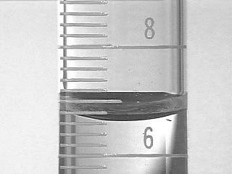
6. 7.

Use the measurements shown in the pictures to answer the questions. Be sure to include units.

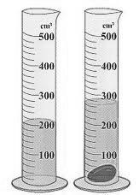

8. What is the volume of the rock in the picture above? ______________________
9. What is the mass of the rock in the picture above?________________________
10. What is the density of the rock in the picture above? _____________________

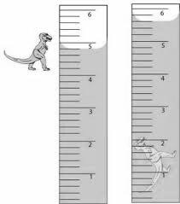

11. What is the volume of the dinosaur figurine in the picture above? ______________________
12. What is the mass of the dinosaur figurine in the picture above?________________________
13. What is the density of the dinosaur figurine in the picture above? _____________________

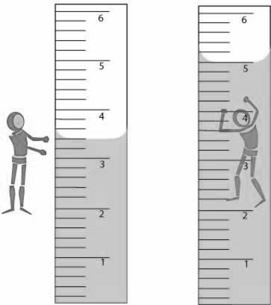

14. What is the volume of the figurine in the picture above? ______________________
15. What is the mass of the figurine in the picture above?________________________
16. What is the density of the figurine in the picture above? _____________________

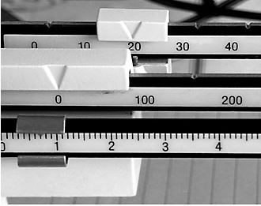
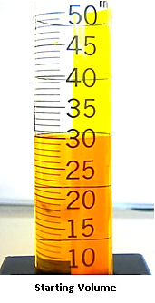
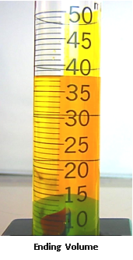

17. What is the volume of the marble in the picture above? ______________________
18. What is the mass of the marble in the picture above?________________________
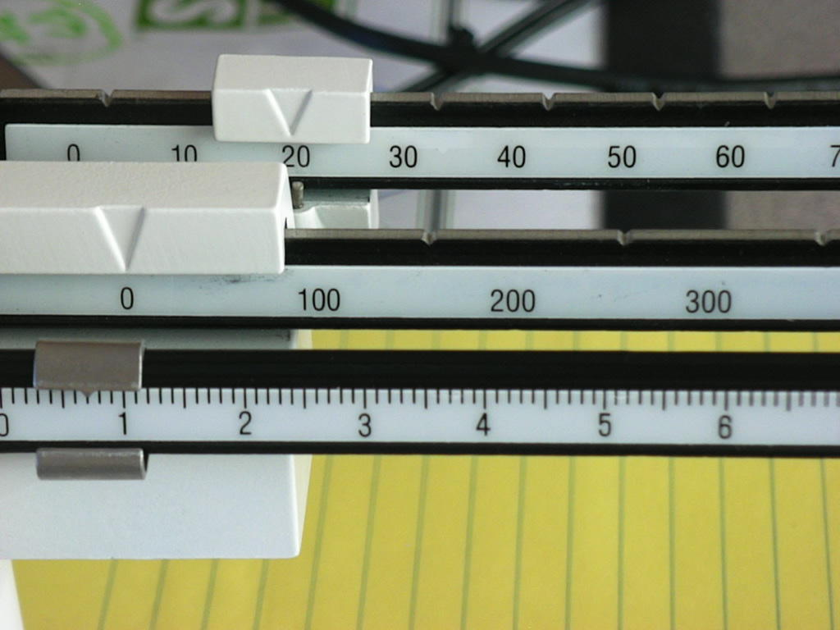
19. What is the density of the marble in the picture above? ______________________
Starting Volume
Balance Scale
Starting Volume
Ending Volume
Balance Scale
Starting Volume
Ending Volume

