Directions: Go to http://learn.genetics.utah.edu/content/variation/reproduction/ and click on the 22 various organisms. Read about each organism, and fill out the chart according to whether they reproduce asexually or sexually. Please give your reason or evidence for choosing that type. When you are finished flip it over to the back and follow directions.

Organism | Type of Reproduction | Evidence for type of reproduction.
1

2

3

4

5

6

7

8

9

10

11

12
13

14

15

16

17

18

19

20

21

Directions: Go to http://learn.genetics.utah.edu/content/variation/reproduction/ and click on the 22 various organisms. Read about each organism, and fill out the chart according to whether they reproduce asexually or sexually. Please give your reason or evidence for choosing that type. When you are finished flip it over to the back and follow directions.

NAME ____________________________ Per. _______

Go to http://www.uen.org/core/science/sciber/sciber7/stand-4/index.shtml and complete the following two sections on the side: “Asexual or Sexual is the Question” and “To Double, Not to Double….That is the Question”.

ASEXUAL OR SEXUAL IS THE QUESTION:

Analysis:
Use a diagram like the circles below to compare and contrast sexual and asexual reproduction. List characteristics about sexual reproduction in the right circle and characteristics of asexual reproduction in the left circle. Where the two circles overlap put characteristics that the two types of reproduction have in common.
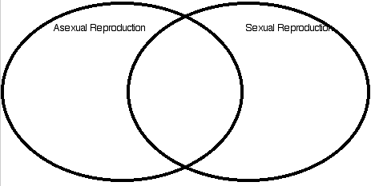
- What are advantages and disadvantages to sexual reproduction?

- What are advantages and disadvantages to asexual reproduction?

- What would you say is the most important difference between the two types of reproduction?

To Double, Not to Double….That is the Question

Directions: Tell me whether each of the following is asexual or sexual.

- Taking a cutting from a house plant-
- Jackrabbits in Utah’s west desert-
- Salmon (an ocean-going fish)-
- Yeast (a fungi with some characteristics like a mushroom)
- Mosquitoes in a nearby pond-

